**Assignment 1**

Your name:    
Your email address:

Once you are done with the 1HEW exercise, email your answers as an attachment to [gogarten@uconn.edu](mailto:gogarten@uconn.edu) and [daniel.s.phillips@uconn.edu](mailto:daniel.s.phillips@uconn.edu)

Objectives for today:

* Know how to install chimera on your computer
* Launch chimera
* Display a 3 D coordinate file from the protein databank (1HEW) in chimera
* Use different display settings
* Display amino acid side chains in the binding pocket of 1HEW and study the interactions between the substrate and the binding pocket.
* Calculate a Ramachandran plot, and determine where in this plot alpha helices, beta sheets, and glycine residues fall.
* Save your work as image, pdb, and project file.

**Introduction and Installing Chimera (not necessary in the computer lab)**

We will use the chimera program to visualize and analyze protein (and other molecular) structures. The program is available for different platforms at <http://www.cgl.ucsf.edu/chimera/download.html>.  If you work on a computer where the software is not already installed, download the current production release for your operating system.  Click on the link, accept the license conditions, and allow the download.  Once the download is completed, install/unpack the downloaded package, or move the chimera.app to your program or application folder.  You might need to do to the systems preferences set-up and give permission to run software you downloaded from the internet!

***Aside 1****:*  We will use chimeraX later in the course for structure prediction, but the alignment of sequences based on structure works less well in chimeraX.

***Aside 2****:*  An alternative, very popular to generate rotating or rocking images is [pymol](http://pymol.org/" \t "_blank). A very simple get-to-know pymol exercise is [here](https://j.p.gogarten.uconn.edu/mcb5472_2012/Laboratories/assign05_2012.html) - it largely corresponding to today's chimera exercise.  If you think protein structures are in your future, you might want to give this a try in your own time.  For many of the more difficult things there are pretty useful YouTube tutorials for either chimera or pymol.

***Aside 3****:* You can retrieve pdb files from the NCBI,  from the [protein structure data bank](http://www.rcsb.org/)at Rutgers University, or from the [European pdb](https://www.ebi.ac.uk/pdbe/). But if you know the name of the protein data bank file (extension pdb) you can use chimera to download the file from within chimera. The ones used in the course are also available [here](https://j.p.gogarten.uconn.edu/bioinf/pdb-files.htm) - we will use 1HEW.pdb and 1bmf.pdb today.

**Exercise 1 :**

**Do the following:**

 Start the program through double clicking the chimera icon (or right click and select open).  Chimera is a program to visualize and analyze protein (and other molecular) structures.

If you manage to obtain a beautiful display of a structure, save the image as a jpg image and save the session (from the file menu) and put an image into your class-note-book.

We will use the structure for [lysozyme](https://en.wikipedia.org/wiki/Lysozyme) crystalized with an inhibitor, a trimer of N-acetyl glucosamine.  The normal substrate for lysozyme the sugar backbone in the cell wall of bacteria.  This [murein sacculus](https://en.wikipedia.org/wiki/Peptidoglycan) surrounds the bacterial cell like a chain link armor, and is creates the cell's turgor pressure in response to the osmotically driven water influx.  When the sugar backbone is cleaved by lysozyme, the elasticity of the cell wall decreases, and the cells explode due to the osmotically driven water influx.  Lysozyme is found in many [throat lozenges](https://www.kiwiimporter.com/explore/blog/read/4/the-surprising-worst-and-best-throat-lozenge-ingredients), egg white,  tears and mucus.  In the normal back bone of the bacterial cell wall, [N-acetylglucosamine](https://en.wikipedia.org/wiki/N-acetylglucosamine) (NAG) and [*N*-acetylmuramic acid](https://en.wikipedia.org/wiki/N-Acetylmuramic_acid) (NAM) are alternating and linked together through a beta 1->4 bond (the same type as in cellulose).  The lactic acid side chain in NAM is used to cross link the sugar polymers through short peptides.  The lactic acid side chain is missing in NAG.  In the structure we use today, the inhibitor (NAG)3 is bound to lysozyme, instead of (NAG-NAM)n, but it is not hydrolyzed, allowing to study the interactions between the substrate and the binding pocket of the enzyme.

* In the chimera program under the file menu, select fetch by ID, place a check-mark in pdb (denoting the protein databank format) and enter 1HEW.  You should see the structure in a ribbon representation, and the inhibitor.  You also see some of the sidechains that are part of the binding pocket.
* Explore the different ways to move the structure with the mouse (click and move, right click and move, option click and move, command click and move).
* Which key/mouse combination allows to zoom into the structure?  Which allows to move the structure sideways or up and down without turning it?

|  |  |
| --- | --- |
| **Your answer --->** |  |

* In the presets menu, explore the different interactive displays.  Return to the ribbon display.

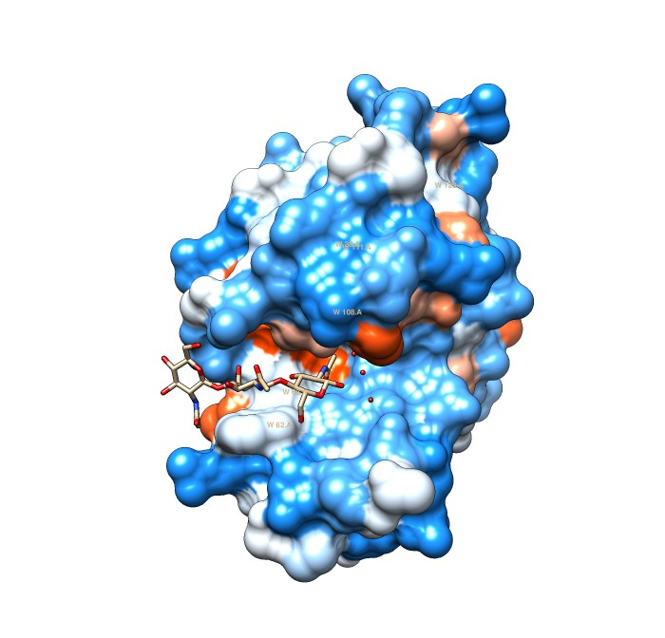

* Open the viewing controls in the tool menu and select side view.  This interactive window allows to relocate the viewpoint and to view only a slab through the structure (you can move the yellow lines, and will see on the slab between the two planes (represented by the two lines).      
  The tabs above the viewing menu also allows you to change the lights and the camera. For example, you could choose a stereo view (under camera > camera mode), but to see this in 3D you need to be good in seeing cross-eyed -- if you want to try it out, switch the camera to cross-eyed stereo, hold a pen or you thumb halfway between the screen and your eye, focus on the pen. If this works, you see three versions of the structure, the one in the middle is in 3D. It might help to adjust the distance between your eyes, and the distance to the screen). Return the camera to normal. Be careful, you might need an aspirin if you try this too long.
* To highlight and color secondary structure elements:    
  *Select > Structure >Secondary Structures > Helix*  , then  
  *Actions > color > red*  (NOTE: actions apply only to the items selected!)  
  *Select > secondary structures > strand* then  
  *Actions > color > yellow*  
  You can leave the coils as they are, or color them in a color of your choice.
* (Alternatively, you can go to Tools > Depiction > color secondary structure and then select colors for the different secondary structural elements.)

Next we will try to study the interactions between the NAG trimer and the binding pocket. As a first step, select and view only the NAG trimer   
Select > Residue > NAG   
Select >Invert  
Action>...>hide (Atoms/bonds)  
Action>...>hide (ribbon) (you should only see the NAG trimer)  
Select > Residue > NAG   
Actions > color > by element

Try to find the C1 and C6 of the hexose molecules; identify the oxygen (red) and nitrogen (blue) atoms. Note where the polar residues point in the chair configuration.   
Because many of the polar residues are sticking out in the equatorial plane of the sugars, the bottom of the sugar molecules is rather hydrophobic.  (Aside: This is the reason for the use of iodine solution in [detecting starch](https://www.youtube.com/watch?v=HO_q8GPl3bE).  Iodine turns blue in hydrophobic solvents.  The sugars in starch form a spiral, and the inside of the spiral consists mainly of C-H residues.  If iodine gets into this environment, it turns bright blue.)  
  
We are interested in the possibility of hydrophobic interactions between the substrate and the sugars.  There are, as usual, many different ways that lead to similar results.

* Possibility 1:   
  *select > chain A   
  Action > Ribbon >show*  
  select the NAG trimer   
  *Select > Residue > NAG*   
  *Select > Zone >* place check mark into "angstroms from currently selected atoms", DO NOT place a check mark into "Select all atoms . . . . "   
  Actions > Atoms/Bonds > sidechain/base > show   
  Then Actions > surface > show   
  (you might need to adjust the coloring  Actions > color by heteroatom works.)  
  Then select the NAG trimer again and hide the surface view.    
  (select > residue > NAG then Actions>surface hide).  
  The result should display the sidechains of the binding pocket as space filling models, with the substrate as wire diagram.  Can you see the interactions between a tryptophan and the sugar?  Which tryptophan interacts with the central NAG?  (Actions > label > name and specifier)
* Possibility 2:  select the NAG trimer   
  Select > Residue > NAG   
  Actions > surface > show   
  Actions > color > by element  
  Select > Zone > place check mark into "angstroms from currently selected atoms , DO not place a check mark into "Select all atoms  . . .  . "  
  Display the side chains of the binding pocket: Actions > Atoms/Bonds > sidechain/base > show   
  Can you see the interactions between a tryptophan and the sugar?  Which tryptophan interacts with the central NAG?  (Actions > label > name and specifier)

* Possibility 3:    
  choose Preset > Interactive 3, to display the hydrophobicity surface.    
  Select > Residue > NAG   
  Actions > surface > hide  
  If you only want to see the binding pocket.   
  Select > Zone > (use 5 Angstrom) place check mark into "angstroms from currently selected atoms , DO not place a check mark into "Select all atoms . . .  ."   
  Select > invert   
  Actions > surface > hide  
  Can you see the interactions between a tryptophan and the sugar?  Which tryptophan interacts with the central NAG?  (Actions > label > name and specifier), you also can hover with the mouse cursor mover the residue

In a few words describe the hydrophobic interactions between the substrate and the enzyme that you see.

|  |  |
| --- | --- |
| **Your answer --->** |  |

Which tryptophan interacts with the central NAG?

|  |  |
| --- | --- |
| **Your answer --->** |  |

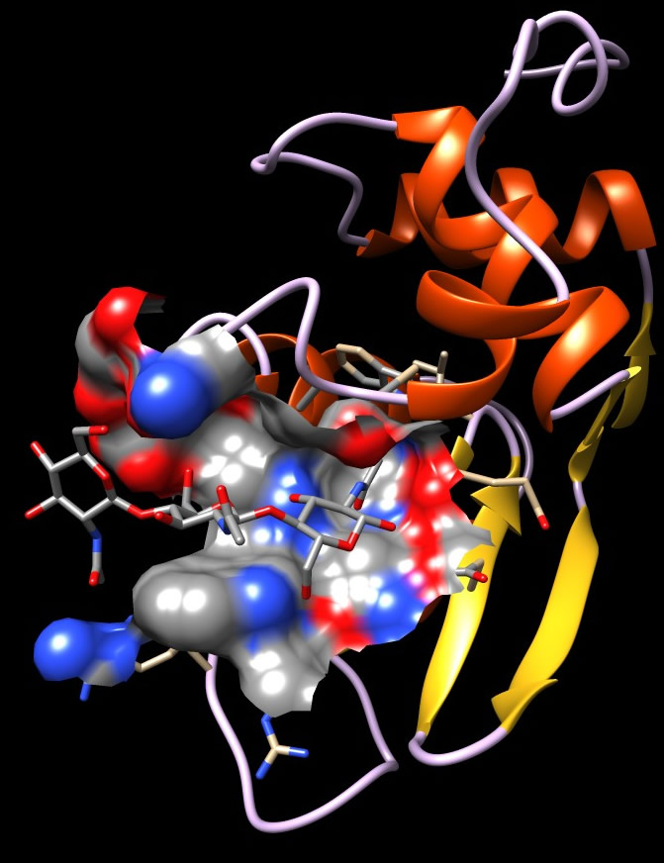

* Obviously. electrostatic interactions and hydrogen bonds play a role.    
  To see the hydrogen bonds, Tools > Structure Analysis > find H Bonds  
  If you apply this to the ribbon structure, you see the many H bonds that stabilize the secondary structural elements.

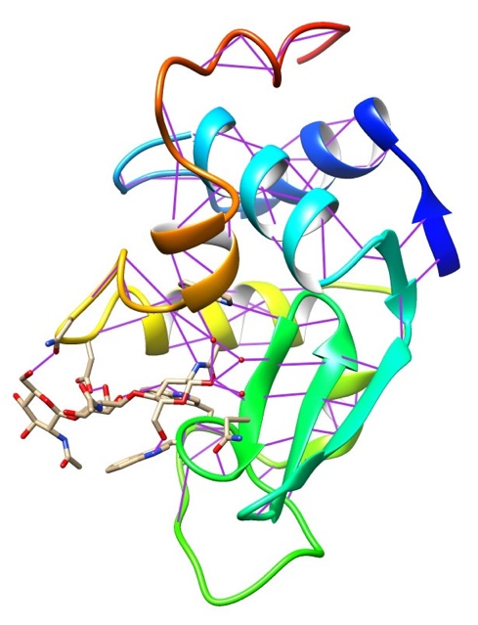

**Calculate and draw a Ramachandran Plot**

The chimera program comes with a command line.    
To see the command line select *Tools > General controls > Command line*.    
[A command line reference is in the chimera user guide (>Help > User's Guide). Some commands can also be executed through the model panel (General controls > model panel).]  
Open the command line window, type ramachandran <return>  
To explore where in the Ramachandran plot different secondary structure elements fall, select the different structural elements (alpha helix, beta sheet (strands), coil), and observe how the color of the selected amino acids changes in the Ramachandran plot.    
Then Select > Residue > Gly.    
Why do glycine residues in the Ramachandran plot often fall outside the areas occupied by the other amino acids?

|  |  |
| --- | --- |
| **Your answer --->** |  |

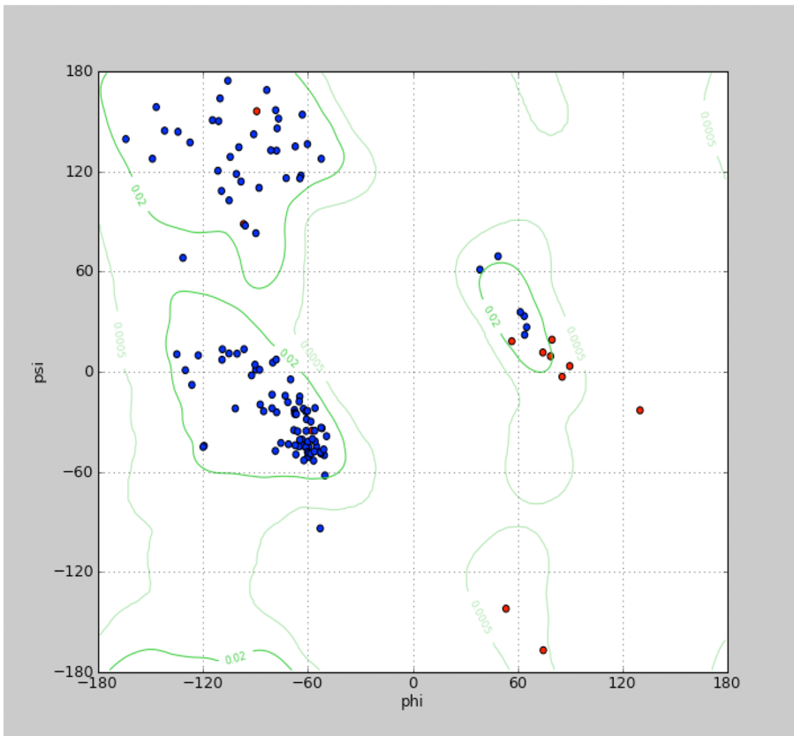

Ramachandran plot for 1HEW with glycine residues in red.

**If you have time, do the following, we will return to this next week!**

**ATPase subunits**

The ATP synthase (aka as proton pumping ATPase) consists of ring of proteolipids that are integrated into the membrane, a head group (which is the structure in 1bmf), and a stator that keep the non-rotating parts fixed.  The head group known as F1 portion of 6 ATP binding subunits (3 alpha and 3 beta subunits).  The beta subunits bind and hydrolyze ATP, if the enzyme works as a proton pumping ATPase.  These catalytic subunits rotate the central gamma subunit.  In the intact enzyme, the gamma subunit is linked to the proteolipids, which than rotate relative to the stator.  When they pass the stator the proteolipids (proteins that behave like a lipid, but they do NOT contain any lipid) they undergo a motion that moves a glutamate or aspartate residue into a different environment, where is picks up or dissociated a proton.

How is ATP synthesis coupled to the electron transport chain? (If this is not obvious, check [here](https://en.wikipedia.org/wiki/Peter_D._Mitchell))

|  |  |
| --- | --- |
| **Your answer --->** |  |

Why is the ATPsynthase important?  Make a guess as to how much ATP are synthesized in the human body per day.

|  |  |
| --- | --- |
| **Your answer --->** |  |

Use Google to verify your estimate.

The beta and alpha subunit evolved from a very ancient gene duplication (this duplication had already occurred in the common ancestor of Bacteria, Archaea, and the eukaryotic nucleocytoplasm); this duplication had already occurred over 3.5 billion years ago (most likely about 4 billion years BP).  This means that the two subunit types (alpha and beta) evolved as separate subunits for over 7 billion (7,000,000,000) years. For comparison: the [age of the known universe](https://en.wikipedia.org/wiki/Age_of_the_universe)is less than 14 billion years.

1) Open chimera and open the 1bmf file (File > fetch by ID 1bmf)   
Look at the structure in the first two preset modes (the surface may take some time to compute).  Note the central gamma subunit (consisting mainly of alpha helices).    
[aside: in the related structure of a transcription termination factor, which unwinds a newly synthesized mRNA from the DNA template, the six ATP binding subunits have a similar arrangement and the place of the gamma subunit is taken by the RNA DNA duplex].  Also color the Ribbon by secondary structure (Tools > depiction > secondary structure).  
Select all non-standard residues (select > residue > ...) and show them as ball (Actions > Surface >show).  Can you determine which chain, via (Select > chain), does not have an ATP or ATP analog bound?

|  |  |
| --- | --- |
| **Your answer --->** |  |