**Assignment 1**

**Your name:    
Your email address:**

Once you are done with the exercise, email your answers as an attachment to [gogarten@uconn.edu](mailto:gogarten@uconn.edu) and [daniel.s.phillips@uconn.edu](mailto:daniel.s.phillips@uconn.edu)

Objectives for today:

* Know how to install chimeraX on your computer
* Launch chimera
* Display a 3 D coordinate file from the protein databank (1HEW) in chimera
* Use different display settings
* Display amino acid side chains in the binding pocket of 1HEW and study the interactions between the substrate and the binding pocket.
* Calculate a Ramachandran plot, and determine where in this plot alpha helices, beta sheets, and glycine residues fall.
* Save your work as image, pdb, and project file.

**Introduction and Installing Chimera (not necessary in the computer lab)**

We will use the chimera program to visualize and analyze protein (and other molecular) structures. The program is available for different platforms at <https://www.cgl.ucsf.edu/chimerax/download.html>.  If you work on a computer where the software is not already installed, download the current production release for your operating system.  (**v1.8)** Click on the link, accept the license conditions, and allow the download.  Once the download is completed, install/unpack the downloaded package, or move the chimera.app to your program or application folder.  **You might need to go to the systems preferences set-up and give permission to run software you downloaded from the internet!**

***Aside****:*  An alternative, very popular to generate rotating or rocking images is [pymol](http://pymol.org/" \t "_blank). A very simple get-to-know pymol exercise is [here](https://j.p.gogarten.uconn.edu/mcb5472_2012/Laboratories/assign05_2012.html) - it largely corresponding to today's chimera exercise.  If you think protein structures are in your future, you might want to give this a try in your own time.  For many of the more difficult things there are useful YouTube tutorials for either chimera or pymol.

***Aside 2****:* You can retrieve pdb files from the NCBI,  from the [protein structure data bank](http://www.rcsb.org/)at Rutgers University, or from the [European pdb](https://www.ebi.ac.uk/pdbe/). But if you know the name of the protein data bank file (extension pdb) you can use chimeraX to download the file from within chimera. The ones used in the course are also available [here](https://j.p.gogarten.uconn.edu/bioinf/pdb-files.htm) - we will use 1HEW.pdb and 1bmf.pdb today.

If you created a nice display, save the structure as a chimeraX session file (extension .cxs). This file keeps the coloring and display options. If you save as a pdb file (pdb Protein Data Bank format), the structural information is saved, but not the display options. However, other programs cannot read the cxs files, thus it is a good idea to save both.   
For copying into your notebook, a screenshot usually is sufficient – on a Mac pressing command control shift 4 simultaneously, gives you a cursor with which you can select part of the screen, which is automatically copied into the clipboard, and you can paste it into your notebook (with command v).

**Exercise 1 :**

**Do the following:**

Start the program through double clicking the chimera v1.8 icon (or right click and select open).  Chimera is a program to visualize and analyze protein (and other molecular) structures.

If you manage to obtain a beautiful display of a structure, save the image as a jpg image and save the session (from the file menu) and put an image into your class-note-book.

We will use the structure for [lysozyme](https://en.wikipedia.org/wiki/Lysozyme) crystalized with an inhibitor, a trimer of N-acetyl glucosamine.  The normal substrate for lysozyme the sugar backbone in the cell wall of bacteria.  This [murein sacculus](https://en.wikipedia.org/wiki/Peptidoglycan) surrounds the bacterial cell like a chain link armor, and is creates the cell's turgor pressure in response to the osmotically driven water influx.  When the sugar backbone is cleaved by lysozyme, the elasticity of the cell wall decreases, and the cells explode due to the osmotically driven water influx.  Lysozyme is found in many [throat lozenges](https://www.kiwiimporter.com/explore/blog/read/4/the-surprising-worst-and-best-throat-lozenge-ingredients), egg white,  tears and mucus.  In the normal back bone of the bacterial cell wall, [N-acetylglucosamine](https://en.wikipedia.org/wiki/N-acetylglucosamine) (NAG) and [*N*-acetylmuramic acid](https://en.wikipedia.org/wiki/N-Acetylmuramic_acid) (NAM) are alternating and linked together through a beta 1->4 bond (the same type as in cellulose).  The lactic acid side chain in NAM is used to cross link the sugar polymers through short peptides.  The lactic acid side chain is missing in NAG.  In the structure we use today, the inhibitor (NAG)3 is bound to lysozyme, instead of (NAG-NAM)n, but it is not hydrolyzed, allowing to study the interactions between the substrate and the binding pocket of the enzyme.

* In the chimeraX program under the file menu, select fetch by ID, place a check-mark in pdb (denoting the protein databank format) and enter 1HEW.  You should see the structure in a ribbon representation, and the inhibitor.  You also see some of the sidechains that are part of the binding pocket.    
  [or type open 1HEW in the command line]

The chimera program comes with a command line.    
To see the command line select *Tools > Command line*.    
A command line reference is in the chimera user guide (>Help > User's Guide). Some commands can also be executed through the model panel (General controls > model panel).

* Explore the different ways to move the structure with the mouse (click and move, right click and move, option click and move, command click and move).
* Which key/mouse combination allows to zoom into the structure?    
  Which allows to move the structure sideways or up and down without turning it?

|  |  |
| --- | --- |
| **Your answer --->** |  |
|  |  |

* In the *presets* menu, explore the different interactive displays.
* In the end, return to the ribbon display.

You also can use the command line, e.g.  
[type preset ribbons or preset cylinders or preset sticks]

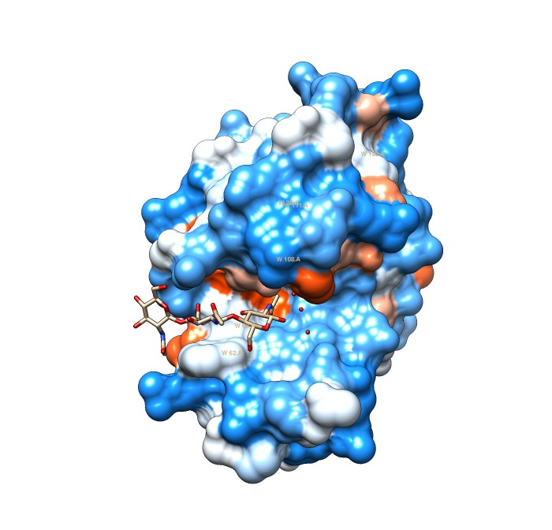

* Open the tool bar on top of the chimera window explore the different background and lighting options.
* Color the ribbon according to secondary structure.  
  Most commands in chimera act only on the selected atoms.   
  There are many ways to select items. The easiest is the Select menu (on top).   
  First unselect everything: Select > Clear

We now will color the ribbon display according to beta sheet (yellow), helices (red), and coils (forest green).   
To do this: *Select* > *Structure* > *Secondary Structure* > *Coil*   
Then: *Action* > *Color* > *Forest Green*  
*Then: Select > Structure >Secondary Structures > Helix*, then  
*Actions > color > red*  (NOTE: actions apply only to the items selected!)  
*Select > secondary structures > strand* then  
*Actions > color > yellow*

Comment: You can choose “select” to act in different ways: add to the already selected items, or replace the previous selection, or ... (see the select menu; replace is usually the best option).

The result should look like this:

Next we will try to study the interactions between the NAG trimer and the binding pocket. As a first step, select and view only the NAG trimer   
Select > Residue > NAG   
Select >Invert  
Action>...>hide (Atoms/bonds)  
Action>...>hide (ribbon) (you should only see the NAG trimer)  
Select > Residue > NAG   
Actions > color > by element

Try to find the C1 and C6 of the hexose molecules; identify the oxygen (red) and nitrogen (blue) atoms. Note where the polar residues point in the chair configuration.   
Because many of the polar residues are sticking out in the equatorial plane of the sugars, the bottom of the sugar molecules is rather hydrophobic.    
(Aside: This is the reason for the use of iodine solution to [detect starch](https://www.youtube.com/watch?v=HO_q8GPl3bE).  Iodine turns blue in hydrophobic solvents.  The sugars in starch form a spiral, and the inside of the spiral consists mainly of C-H residues.  If iodine gets into this environment, it turns bright blue.)  
  
We are interested in the possibility of hydrophobic interactions between the substrate and the sugars.  There are, as usual, many different ways that lead to similar results.

* Possibility 1:   
  *select > chain A   
  Action > Ribbon >show*  
  select the NAG trimer   
  *Select > Residue > NAG*   
  *Select > Zone > In the pop-up window select the following* *A screenshot of a phone

  Description automatically generated* Click apply

Then  
Actions > Atoms/Bonds > sidechain/base > show   
Then Actions > Atoms/Bonds > Atom Style > sphere   
(you might need to adjust the coloring:  Actions > color by heteroatom works.)  
Then select the NAG trimer again and hide the sphere view.    
(select > residue > NAG then Actions > Atoms/Bonds > Atom Style > stick ).  
The result should display the sidechains of the binding pocket as space filling models, with the substrate as wire diagram.  Can you see the interactions between a tryptophan and the sugar?  Which tryptophan interacts with the central NAG?  (Actions > label > name and specifier)

* Possibility 2:  select the NAG trimer   
  Select > Residue > NAG   
  Actions > Atoms/Bonds > Atom Style > sphere   
  Actions > color > by element  
  Select > Zone > place check mark into "angstroms from currently selected atoms. Display the side chains of the binding pocket: Actions > Atoms/Bonds > sidechain/base > show   
  Can you see the interactions between a tryptophan and the sugar?  Which tryptophan interacts with the central NAG?  (Actions > label > name and specifier, or hover with the mouse pointer of the amino acid you want to identify)

* Possibility 3:    
  In the top menu bar select “Molecule display”   
  then select electrostatic.    
  Select > Residue > NAG   
  Actions > Atoms/Bonds > Atom Style > stick  
    
  Can you see the interactions between a tryptophan and the sugar?  Which tryptophan interacts with the central NAG?  (Actions > label > name and specifier), you also can hover with the mouse cursor mover the residue.

Surface hydrophilicity (blue) and electrostatic coloring (red negative) of the 1HEW surface

In a few words describe the hydrophobic interactions between the substrate and the enzyme that you see.

|  |  |
| --- | --- |
| **Your answer --->** |  |

Which tryptophan interacts with the central NAG?

|  |  |
| --- | --- |
| **Your answer --->** |  |

* Obviously electrostatic interactions and hydrogen bonds also play a role in substrate binding.    
  To see the hydrogen bonds: Tools > Structure Analysis > H Bonds  
  If you apply this to the ribbon structure, you see the many H bonds that stabilize the secondary structural elements.

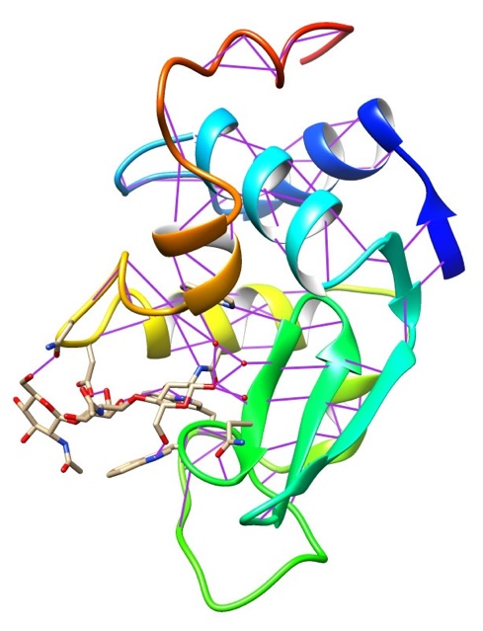

**Calculate and draw a Ramachandran Plot**

ChimeraX has not yet implemented the Ramachandran plot. You need to use the old version of chimera.

Start the old version of chimera.   
*File > Fetch by ID* enter 1HEW   
*Tools > General controls > Command line*.    
Type ramachandran <return>  
To explore where in the Ramachandran plot different secondary structure elements fall, select the different structural elements (alpha helix, beta sheet (strands), coil), and observe how the color of the selected amino acids changes in the Ramachandran plot.    
Then Select > Residue > Gly.

Why do glycine residues in the Ramachandran plot often fall outside the areas occupied by the other amino acids?

|  |  |
| --- | --- |
| **Your answer --->** |  |

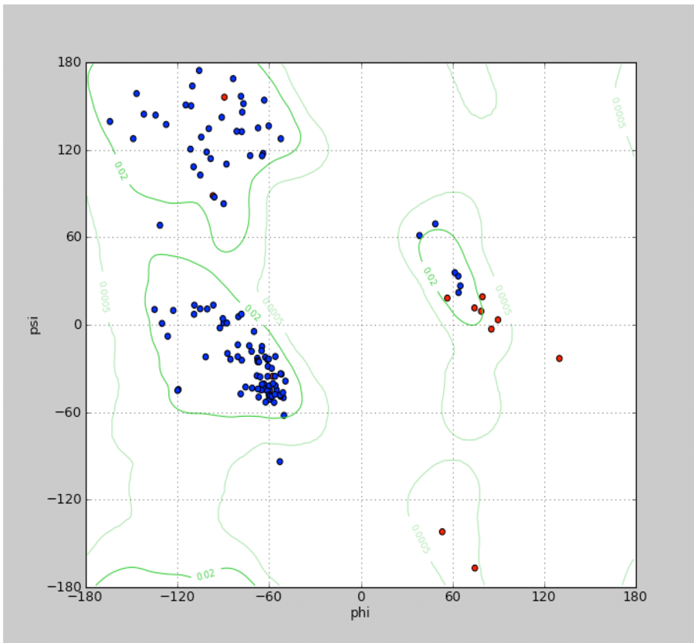

Ramachandran plot for 1HEW with glycine residues in red.

**Back to chimeraX**

Many tutorials have been developed for chimerax. You can access the tutorial from inside chimeraX. A really nice one is the one on the ATPsynthase from *Bacillus* PS3. In *Help > Tutorials* scroll down to

The tutorial will open within chimeraX. Glance through the paragraphs on top, then click on the first link under Opening PDB models. This is a command that can be copied into the command line (turn on under *Tools*), but you also can execute it by clicking in the tutorial ... ☺

The sequence command displays the primary sequence. If you select residues in the sequence window, they also will be selected in the structure. For example, the ATP binding site has a so-called [Rossmann-fold](https://www.ncbi.nlm.nih.gov/pmc/articles/PMC7870570/). This fold is present in about 25% of all know protein structures. The Rossmann folds are characterized by the Walker A and B motifs. The Walker A motif is G-x(4)-GK-[TS], most often GxxxxGKT.

If you select the GKT in the sequence, and then *action > color > red*, the residues will also be colored in the structure. (You need to do preset ribbon to see inside the molecule).

Work through the tutorial on **Display styles** and **Morphing between 3 conformations**. This is a lot of clicking, but it results in a nice movie.